INFORMATION TECHNOLOGY DEPARTMENT

SELF LEARNING ASSESMENT MINI PROJECT REPORT
Submitted in partial fulfillment of the requirements of the
DIPLOMA course by:

NAME OF THE STUDENT:- | Rishik Jariwala
ROLL NO:- | T023
SAP ID:- | 57508240026
PROJECT TOPIC:- | KutumbSetu
COURSE:- | #Development & Operations (DevOps) (DEV230913)
SEMESTER:- | V
ACADEMIC YEAR:- | 2026 -2027
ACADEMIC TERM:- | 01/07/2026 – 19/10/2026
NAME OF THE DEPARTMENT:- | INFORMATION TECHNOLOGY
SIGNATURE OF FACULTY

INFORMATION TECHNOLOGY DEPARTMENT

FIFTH SEMESTER

Course: # Development & Operations (DevOps) |  | Course Code: DEV230913
CO No. | COURSE OUTCOME
CO1 | Recognize basic concepts of Development & Operations
CO2 | Interpret and apply various principles, phases, and activities of Agile methodology
CO3 | Manage Source Code using Version Control System
CO4 | Build applications using the process of Continuous Integration
CO5 | Perform automated testing of DevOps application
CO6 | Use Configuration Management tools using Containerization

CERTIFICATE

THIS IS TO CERTIFY THAT
MR. RISHIK JARIWALA
HAS SATISFACTORILY COMPLETED HIS SELF LEARNING ASSIGNMENT IN PARTIAL FULFILMENT OF THE REQUIREMENTS OF THE
DIPLOMA COURSE IN INFORMATION TECHNOLOGY
FACULTY | HEAD OF DEPARTMENT (I.T.) | PRINCIPAL

TABLE OF CONTENTS
1. Introduction 6
2. Objectives 6
3. Software / Hardware Requirements 7
3.1 Software Requirements 7
3.2 Hardware Requirements 9
4. Technologies Used 9
4.1 Git and GitHub 9
4.2 Jenkins 10
4.3 Appium / Mobile Application Testing Tool 10
4.4 Docker and Containerization 10
4.5 MongoDB and Database Connectivity 10
4.6 Ansible / Chef Configuration Management 11
5. DevOps Concepts Used 11
5.1 Version Control and Repository Management 11
5.2 Git Operations: Push, Pull and Pop 12
5.3 Continuous Integration and Automation Using Jenkins 12
5.4 Mobile Application Testing and Automation 13
5.5 Docker Images, Containers and Networking 13
5.6 Configuration Management and Software Installation Automation 14
6. System / Project Description 14
7. Application Features 15
8. System Architecture and Component Structure 15
8.1 Flutter Mobile Application 16
8.2 Node.js / Express Backend 16
8.3 MongoDB Database 16
8.4 DevOps Tools Integration 17
9. Working / Implementation 17
9.1 GitHub Repository Setup and Version Control 17
9.2 Jenkins Installation and Application Execution 18
9.3 Mobile Application Testing Using Appium 19
9.4 Docker Image Creation and Database Connectivity 20
9.5 Automated Software Installation Using Ansible / Chef 21
10. Important Commands and Configuration Files 22
10.1 Git Commands and Repository Operations 22
10.2 Jenkins Configuration and Build Execution 23
10.3 Appium Test Script and Test Configuration 23
10.4 Dockerfile and Container Execution Commands 24
10.5 Database Connection Configuration 24
10.6 Ansible Playbook / Chef Configuration 25
11. Screenshots of DevOps Implementation 25
11.1 GitHub Repository and Git Operations 26
11.2 Jenkins Home Page and Successful Execution 27
11.3 Mobile Application Testing Results (Appium) 30
11.4 Docker Image and Container Execution 33
11.5 Ansible Playbook and Automation Execution Results 35
12. Summary of DevOps Implementation 39
13. Conclusion 40
14. References 40
LIST OF FIGURES
Figure 11.1 – GitHub Repository and Git Operations 26
Figure 11.2 – Jenkins Dashboard and Application Pipeline Execution 27
Figure 11.3 – Mobile Application Testing with Appium on Android 30
Figure 11.4 – Docker Backend Build and Running Container 33
Figure 11.5 – Login & Database Connectivity Verification (MongoDB) 34
Figure 11.6 – Ansible Playbook Automation Execution Results 35

1. Introduction
DevOps is a combination of software development and IT operations practices that aims to improve collaboration, automation, testing, deployment and maintenance of software applications. It helps developers manage source code, automate repetitive tasks, identify errors early and maintain consistency across development environments.
The primary purpose of this DevOps Self-Learning Assessment (SLA) is to apply DevOps tools and practices to the development workflow of KutumbSetu (कुटुम्बसेतु), a community management mobile application developed for Samast Darji Samaj, Babariyawad.
The project uses Flutter and Dart for mobile application development, Node.js and Express.js for backend services, and MongoDB for database management. The DevOps activities include maintaining the project on GitHub, installing Jenkins on Windows, testing the mobile application using an approved automation tool, creating a Docker image for the login/registration component with database connectivity, and automating software installation using Ansible or Chef.
These activities demonstrate how version control, continuous integration concepts, automated testing, containerization and configuration management can support a more organized software development process.

2. Objectives
The main objectives of this DevOps SLA are:
- To maintain the KutumbSetu project source code using Git and GitHub.
- To understand and demonstrate Git operations such as push, pull and pop-related workflows.
- To install Jenkins on Windows and demonstrate the execution of the application's home page or a suitable project build.
- To test the KutumbSetu mobile application using Appium or another faculty-approved testing tool.
- To create a Docker image for the login/registration component and demonstrate database connectivity.
- To automate the installation and configuration of required project software using Ansible or Chef.
- To understand the role of automation, version control, testing and containerization in software development.
- To document the implementation process with commands, configuration files, screenshots and test results.

3. Software / Hardware Requirements
The project requires software development tools, source-control utilities, automation tools, a database and suitable computer hardware. The exact requirements depend on the selected testing and configuration-management tools.
Software / Tool | Purpose
Windows 10/11 | Operating system for development and tool installation
Flutter SDK and Dart | Mobile application development
Android Studio / Android SDK | Android build tools and emulator/device support
Visual Studio Code | Source-code editing and project management
Git | Version control and repository operations
GitHub | Remote source-code repository and collaboration
Node.js and npm | Backend runtime and dependency management
Express.js | Backend API development
MongoDB | Database storage
Jenkins | Build and execution automation
Appium or approved alternative | Mobile application testing
Docker Desktop | Container image creation and execution
Ansible or Chef | Software installation and configuration automation
Postman | Optional API testing and verification
Web browser | Accessing Jenkins, GitHub and web-based interfaces

3.2 Hardware Requirements
The following are suggested development requirements, not measured specifications of your computer.
Component | Suggested requirement
Processor | Intel Core i3 or equivalent; i5/Ryzen 5 recommended
RAM | 8 GB minimum; 16 GB recommended for emulators and containers
Storage | At least 20–30 GB of free space for project tools and build files; additional space may be required
Display | 1366 × 768 or higher
Internet | Stable connection for downloading dependencies and using GitHub
Android device | Optional, for testing the application on physical hardware
USB cable | Optional, for connecting a physical Android device

4. Technologies Used
The following technologies support the implementation of the five DevOps SLA tasks.

4.1 Git and GitHub
Git is a distributed version-control system used to track changes in source code. It allows developers to create commits, compare changes, restore earlier versions and work with branches.
GitHub is a cloud-based platform used to host Git repositories. It allows project code to be stored remotely and shared with other developers.
In KutumbSetu, Git and GitHub can be used to maintain the Flutter source code, backend code, configuration files and documentation. They also provide a way to recover committed code if an accidental deletion occurs.

4.2 Jenkins
Jenkins is an automation server used to execute repeatable software-development tasks. It can run build commands, perform tests and execute configured jobs.
For this SLA, Jenkins is installed on Windows. A suitable job can be configured to run a command, build a component or launch a project page, depending on the project's architecture and the task requirements.
Jenkins can later be integrated with GitHub so that source-code changes trigger automated builds.

4.3 Appium / Mobile Application Testing Tool
Appium is an open-source automation framework for testing mobile applications. It allows automated interactions with application elements, including buttons, text fields and navigation controls.
For KutumbSetu, a suitable test can verify that the login screen opens, input fields are available, and navigation behaves as expected. Authentication tests should use a test account and a controlled test environment.
Appium requires a compatible driver, a running application or emulator/device, and suitable test scripts. If another approved tool is selected, document that tool's actual setup and test process instead.

4.4 Docker and Containerization
Docker is a containerization platform that packages an application and its required dependencies into a consistent environment.
A Docker image is a template used to create containers. A container is a running instance of an image.
For this SLA, Docker is used to package the login/registration component or the relevant service that supports it. The resulting container should be tested to confirm that it starts correctly and can communicate with the configured database.

4.5 MongoDB and Database Connectivity
MongoDB is a NoSQL document database that stores data in flexible, JSON-like documents. KutumbSetu uses MongoDB to store application data such as member profiles and other supported community records.
The Node.js backend connects to MongoDB using an appropriate driver or ODM, such as the MongoDB Node.js driver or Mongoose.
When a Docker container accesses MongoDB, the connection string must refer to a reachable database host. For example, localhost inside a container refers to that container itself, not automatically to the host computer. Docker networking or a suitable external database address must therefore be configured.

4.6 Ansible / Chef Configuration Management
Ansible and Chef are configuration-management and automation tools that help automate software installation and environment setup.
Ansible uses playbooks, generally written in YAML, to define tasks such as installing packages, creating directories and configuring services. Chef uses recipes and cookbooks to describe system configuration.
For this SLA, one of these tools is used to automate installation or configuration of selected software required by the project. The report should include the actual configuration file, execution command and verification output.

5. DevOps Concepts Used

5.1 Version Control and Repository Management
Version control is the process of recording and managing changes made to project files. Git stores the history of committed changes, making it easier to track modifications and recover earlier versions.
A repository contains the project's source files and their version history. A local repository is stored on the developer's computer, while a remote repository such as GitHub makes the code available online.
Important Git concepts include:
- Repository: Stores project files and version history.
- Commit: Records a set of changes.
- Branch: Provides an independent line of development.
- Push: Uploads local commits to a remote repository.
- Pull: Fetches and integrates changes from a remote repository.
- Stash: Temporarily saves uncommitted changes.
- Pop: Reapplies stashed changes and removes the stash entry when successful.
Git helps protect the KutumbSetu source code and supports collaborative development.

5.2 Git Operations: Push, Pull and Pop
Git push and pull are remote-repository operations, whereas pop is commonly used with Git stash.
The following commands demonstrate the basic workflow:
git status
git add .
git commit -m "Save project changes"
git push origin main
git pull origin main
To temporarily save uncommitted changes and reapply them later:
git stash
git stash pop
The git stash command saves supported uncommitted changes temporarily. The git stash pop command reapplies the saved changes and removes the stash entry if the operation succeeds. Conflicts may occur if the same lines have changed elsewhere.
Important: The commands should be demonstrated in a repository configured with the correct remote and branch. If the faculty specifically asks for Git “push and pop,” explain the distinction and demonstrate the operation intended by the instructor.

5.3 Continuous Integration and Automation Using Jenkins
Continuous Integration (CI) is a development practice in which code changes are regularly integrated and checked through automated processes.
Jenkins supports CI by running configured jobs that can execute build commands, run tests and report failures. A Jenkins job can be configured to run a command whenever the developer starts the job manually, or automatically when an appropriate trigger is configured.
For KutumbSetu, Jenkins can execute a suitable build or verification command for the selected project component. For example, a Node.js backend can be checked by installing dependencies and running its configured test or start command. A Flutter component can be checked using Flutter's analysis or build commands if the required SDK is available to Jenkins.
A successful Jenkins dashboard opening alone proves that Jenkins is running; a successful job execution provides additional evidence that the configured task completed.

5.4 Mobile Application Testing and Automation
Mobile application testing checks whether an application behaves correctly on a supported device or emulator.
Automated testing uses scripts to perform repeatable actions and verify expected outcomes. With Appium, a test script can launch an application, locate interface elements, enter test data, tap buttons and inspect the resulting screen.
For KutumbSetu, test cases may include:
- Launching the application.
- Verifying that the login screen appears.
- Checking that email and password or other required input fields are present.
- Entering test data.
- Tapping the login or registration button.
- Checking the resulting message or screen.
- Recording the test result.
A test should be marked successful only when its expected behavior has been observed. Testing a screen's presence does not by itself prove that backend authentication or database operations work correctly.

5.5 Docker Images, Containers and Networking
Containerization packages an application with its runtime requirements so that it can run in a consistent environment.
The main Docker concepts are:
- Dockerfile: Contains instructions used to build an image.
- Image: A packaged template for creating containers.
- Container: A running instance of an image.
- Port mapping: Makes a container service accessible through a host port.
- Environment variables: Supply configuration values at runtime.
- Docker network: Allows containers to communicate with each other.
For the login/registration SLA, the selected application component is packaged into an image and run as a container. If the component requires MongoDB, the database must be reachable using the correct connection configuration.
Database credentials should not be embedded directly in the image. They should be supplied through an appropriate environment configuration or secrets mechanism.

5.6 Configuration Management and Software Installation Automation
Configuration management automates the setup and maintenance of software environments. It reduces repetitive manual work and makes installation procedures easier to repeat.
Ansible defines tasks in playbooks, while Chef defines configuration through recipes and cookbooks. Both can automate selected activities such as installing packages, creating directories and configuring services, subject to the operating system and tool setup.
For this SLA, the chosen tool is used to configure software needed for the development environment. The result is verified by checking the installed software's version or confirming that the relevant service is running.

6. System / Project Description
KutumbSetu is a community management mobile application designed to support digital communication and information management for Samast Darji Samaj, Babariyawad.
The application is developed using Flutter and Dart for the mobile interface, Node.js and Express.js for backend APIs, and MongoDB for persistent data storage.
The application is intended to bring community information and supported services into one platform. Depending on the implemented modules, these may include member profiles, a community directory, family relationships, matrimonial information, announcements, events and a voluntary blood-donor directory.
The DevOps SLA applies tools and practices to the project's development and testing workflow. Git and GitHub are used for source-code management, Jenkins is used for automation, Appium or an approved alternative is used for mobile testing, Docker is used for containerization, and Ansible or Chef is used for software-installation automation.
The objective is to demonstrate how these tools can make development work more organized, repeatable and easier to verify.

7. Application Features
The following features may be documented for KutumbSetu, subject to confirmation against the actual application build.
- User Authentication and Profile Management: Allows users to register, sign in and manage their permitted profile information.
- Community Directory: Helps users locate community members using supported search and filtering options.
- Family Tree: Organizes family relationships where this module is implemented.
- Matrimonial Portal: Supports matrimonial profiles and related interactions according to the application's implemented functionality.
- Community Feed and Announcements: Displays supported community updates, announcements and achievements.
- Campaign and Event Management: Provides information about community campaigns and events.
- Blood Donor Registry: Provides a voluntary directory of donors if this module is available.
- Language and Theme Options: Provides language selection and appearance options if implemented.
The primary feature selected for the Docker SLA is the login/registration component, because it allows the report to demonstrate a user interface, backend communication and database connectivity.

8. System Architecture and Component Structure
KutumbSetu follows a client-server architecture in which the mobile application communicates with backend APIs, and the backend interacts with the database.
The general data flow is:
Flutter Mobile Application
Screens, forms and user interaction
Node.js / Express Backend
API routes, validation and business logic
MongoDB Database
Persistent application records
DevOps tools support the workflow around these components: Git/GitHub for source control, Jenkins for automation, a mobile testing tool for verification, Docker for packaging, and Ansible/Chef for environment setup.
This diagram shows the logical application architecture. It does not imply that every DevOps tool is already integrated into an automated pipeline.

8.1 Flutter Mobile Application
Flutter is the framework used to develop the KutumbSetu mobile interface. Dart is the programming language used by Flutter.
The mobile application contains screens, input fields, buttons, navigation and other user-interface elements. When a user performs an action, the relevant application logic may send an API request to the backend and display the response.
For the DevOps SLA, the Flutter application is the primary target for mobile application testing.

8.2 Node.js / Express Backend
Node.js provides the JavaScript runtime for the backend, while Express.js provides a framework for defining HTTP routes and middleware.
The backend receives requests from the mobile application, validates the input, executes the required application logic and communicates with MongoDB when necessary. It then sends an appropriate response to the client.
The backend is also relevant to the Docker experiment if the login/registration service is packaged as a container.

8.3 MongoDB Database
MongoDB stores the application's persistent data in documents grouped into collections. The backend accesses the database using its configured connection method.
Database connectivity depends on the correct connection string, network access, authentication settings and database availability. During testing, the application should be checked to confirm that valid requests reach the backend and that expected data operations succeed.
For documentation, use the actual database configuration from the project but do not publish passwords, private connection strings or secret keys.

8.4 DevOps Tools Integration
The DevOps tools have separate responsibilities within the development workflow:
- Git/GitHub preserve source-code history and remote backups.
- Jenkins runs configured jobs and automated commands.
- Appium or another approved tool verifies mobile application behavior.
- Docker packages and runs the selected component in a container.
- Ansible or Chef automates selected software installation and configuration tasks.
These tools can be integrated further in the future, for example by triggering Jenkins builds after GitHub changes. Such integration should be described as completed only if it has actually been configured and tested.

9. Working / Implementation
This section describes the implementation procedure for the five DevOps SLA tasks. Replace example paths, branch names, ports and commands with those used in your actual environment.

9.1 GitHub Repository Setup and Version Control
Aim: To maintain the KutumbSetu source code using Git and GitHub and demonstrate repository operations.
Procedure:
- Install Git and configure the username and email used for commits.
- Open the KutumbSetu project directory in a terminal.
- Check whether the project is already a Git repository.
- If it is already connected to GitHub, inspect its remote URL and current branch.
- Stage and commit the intended project changes.
- Push the commits to the configured GitHub branch.
- Demonstrate the relevant stash operation if required by the SLA.
- Verify the changes on GitHub.
Example commands:
git --version
git status
git branch --show-current
git remote -v
git add .
git commit -m "Update KutumbSetu project"
git push origin main
For a project already configured with Git, do not run git init or overwrite the remote without checking its current configuration. Replace main with the actual branch name.
To demonstrate stash and pop:
git stash
git stash list
git stash pop
git status
Verification: Confirm that the commit exists in the local history and that the pushed commit is visible in the GitHub repository. For stash operations, verify that the saved changes are reapplied correctly.

9.2 Jenkins Installation and Application Execution
Aim: To install Jenkins on Windows and demonstrate a configured job that executes a suitable project task.
Procedure:
- Install a supported Java runtime or JDK version compatible with the selected Jenkins release.
- Download and install Jenkins using the appropriate Windows installer.
- Start the Jenkins service and open the Jenkins URL in a browser, commonly http://localhost:8080.
- Complete the initial setup and create an administrator account.
- Open the Jenkins dashboard and create a new job.
- Configure the job to execute an appropriate command for the selected KutumbSetu component.
- Save the job and click Build Now.
- Open the build history and inspect Console Output.
- Capture the dashboard and the job execution result.
For example, a job could run a backend verification command such as:
node --version
npm --version
A more meaningful job should run the actual project's test, analysis or build command, where configured and supported.
Important: Jenkins opening successfully is not the same as building the app successfully. If your SLA specifically requires the website/app home page to run, document how the configured job launches or verifies that page. For a Flutter mobile app, explain the chosen build or execution method instead of treating it as a normal web page.
Verification: Record whether the Jenkins dashboard opens, whether the job runs and whether its console output shows the expected result.

9.3 Mobile Application Testing Using Appium
Aim: To test the KutumbSetu mobile application using Appium or another permitted mobile testing tool.
Procedure:
- Install Node.js and the required Appium tooling.
- Install the appropriate Appium driver for the chosen platform.
- Prepare an Android emulator or a compatible physical device.
- Enable the required developer settings on the test device, if applicable.
- Build and install the KutumbSetu APK.
- Start the Appium server and configure the test script.
- Launch the application through the test script.
- Verify the login screen and perform selected interactions.
- Record the expected and actual results.
A sample test scenario is:
Step | Action | Expected result
1 | Launch the application | Application opens
2 | Locate the login screen | Login screen is displayed
3 | Locate the required input fields | Fields are available
4 | Enter test data | Input is accepted
5 | Tap the login button | Expected validation or authentication response appears
6 | Review the result | Pass/fail outcome is recorded
The actual test script must use the element identifiers and application capabilities that exist in your build.
Verification: Capture the test execution and report which test cases passed or failed. Do not mark the authentication flow as passed solely because the login button can be tapped.

9.4 Docker Image Creation and Database Connectivity
Aim: To create a Docker image for the login/registration component and demonstrate that the running component can connect to the database.
Procedure:
- Identify the component that implements the login/registration workflow.
- Determine whether the selected component is a Flutter interface, a backend API or a web frontend. These require different containerization approaches.
- Create a Dockerfile appropriate for the selected component.
- Configure the required dependencies and runtime command.
- Build the Docker image.
- Run a container and map the required port, where applicable.
- Supply the database connection configuration securely.
- Check the container logs and test the relevant login/registration request.
- Verify that the backend can communicate with MongoDB and perform the intended database operation.
Example commands for a Node.js backend with a suitable Dockerfile:
docker --version
docker build -t kutumbusetu-backend .
docker images
docker run --name kutumbusetu-backend -p 3000:3000 kutumbusetu-backend
docker ps
docker logs kutumbusetu-backend
These are examples; the port, image name, runtime command and environment configuration must match your implementation. A backend that uses MongoDB needs a reachable database endpoint and the appropriate credentials. If MongoDB is running in another container, configure a Docker network and use the database container's service name.
Verification: Confirm that the image builds, the container starts, the login/registration endpoint responds as expected, and the relevant database operation succeeds.

9.5 Automated Software Installation Using Ansible / Chef
Aim: To automate the installation or configuration of selected project software using Ansible or Chef.
Procedure using Ansible:
- Prepare a supported Linux or WSL environment.
- Install Ansible in that environment.
- Identify the software packages required for the demonstration.
- Create a playbook describing the selected installation/configuration tasks.
- Run the playbook against the intended local or remote target.
- Check the output for successful task completion.
- Verify the installed software using version commands or service checks.
A basic illustrative playbook for a Debian-based target is:
---
- name: Configure development utilities
hosts: localhost
connection: local
become: true

tasks:
- name: Install Git
ansible.builtin.apt:
name: git
state: present
update_cache: true
Save it as setup.yml. This example installs Git on a compatible Debian-based environment; it does not install the entire KutumbSetu development stack.
Run it in the supported environment:
ansible --version
ansible-playbook setup.yml --ask-become-pass
git --version
If you choose Chef instead, replace the playbook with the actual Chef recipe/cookbook and include the commands and output from that implementation.
Verification: Confirm that the playbook or recipe executes without relevant errors and that the selected software is installed or configured as intended.

10. Important Commands and Configuration Files

10.1 Git Commands and Repository Operations
Command | Purpose
git --version | Checks the Git installation
git status | Displays the working-tree status
git add . | Stages changes in the current directory
git commit -m "message" | Records staged changes
git push origin main | Pushes commits to the remote branch
git pull origin main | Fetches and integrates remote changes
git stash | Temporarily saves supported uncommitted changes
git stash list | Lists saved stashes
git stash pop | Reapplies a stash and removes it if successful
git log --oneline | Displays a compact commit history
Commands involving main should be changed to the actual branch name when necessary.

10.2 Jenkins Configuration and Build Execution
Jenkins is configured through its web interface, job settings and, where required, a Jenkinsfile.
A simple illustrative Jenkinsfile for a Node.js backend is:
pipeline {
agent any

stages {
stage('Check Environment') {
steps {
bat 'node --version'
bat 'npm --version'
}
}
}
}
This example checks the installed Node.js and npm versions on a Jenkins agent running Windows. It does not build or test the complete application.
For an actual application job, use the correct project directory and add suitable installation, testing or build stages. Document the real pipeline used for the demonstration.

10.3 Appium Test Script and Test Configuration
Appium test automation normally includes:
- Appium server configuration.
- A compatible driver and client library.
- Device/emulator details.
- Application package or APK location.
- Test scripts and element locators.
A test script should launch the application, interact with the relevant screen and assert expected results. The exact code depends on the chosen programming language, Appium client library, Android driver and application identifiers.
Include the actual test script in the report, along with a short explanation of its important commands and assertions.

10.4 Dockerfile and Container Execution Commands
An illustrative Dockerfile for a Node.js backend is:
FROM node:22-alpine

WORKDIR /app

COPY package*.json ./
RUN npm ci

COPY . .

EXPOSE 3000

CMD ["npm", "start"]
This example assumes that the project has a compatible lockfile and a valid start script in package.json. Select a supported Node.js image compatible with your project dependencies.
Build and run the image using the commands in Section 9.4. Add a .dockerignore file to exclude unnecessary files such as node_modules, local build output and secret files.
If the SLA requires a containerized login/registration page rather than only the backend, describe how that page is served and how requests reach the backend. A Flutter mobile interface is not automatically converted into a browser-based login page simply by containerizing its API.

10.5 Database Connection Configuration
A Node.js backend can connect to MongoDB using the official driver or Mongoose. An illustrative environment variable is:
MONGODB_URI=mongodb://127.0.0.1:27017/kutumbusetu
This URI is only suitable when MongoDB is reachable at that address from the backend process. In a container, the hostname must be adjusted to the configured network location.
The backend should read the connection string from its environment configuration rather than hardcoding credentials into source files.
For a container, configuration can be supplied at runtime, for example:
docker run --env-file .env -p 3000:3000 kutumbusetu-backend
Use this only if the application is designed to read those variables and the .env file contains the required configuration. Keep secret files out of Git and do not include actual credentials in the blackbook.

10.6 Ansible Playbook / Chef Configuration
For Ansible, the main configuration artifact is the YAML playbook. It specifies the target hosts, connection settings, privilege requirements and tasks.
For Chef, the equivalent documentation may include:
- Cookbook structure.
- Recipe file.
- Resource declarations.
- Target-node configuration.
- Execution command and verification output.
Include the actual file used in your implementation. Explain the purpose of the important fields, such as hosts, tasks, name, state and the selected package/resource.
The configuration should be appropriate for the actual target operating system. Do not claim that Windows software was installed using a Linux-only package module unless the execution environment supports that operation.

11. Screenshots of DevOps Implementation
This section provides visual evidence of the execution of the five SLA tasks. Insert screenshots captured from your own computer and give each screenshot a figure number and descriptive caption.

11.1 GitHub Repository and Git Operations
Insert a screenshot of the KutumbSetu repository on GitHub. Include a terminal screenshot showing relevant Git commands and their output.
Figure 11.1 – GitHub Repository and Git Operations
The file where the code was changed
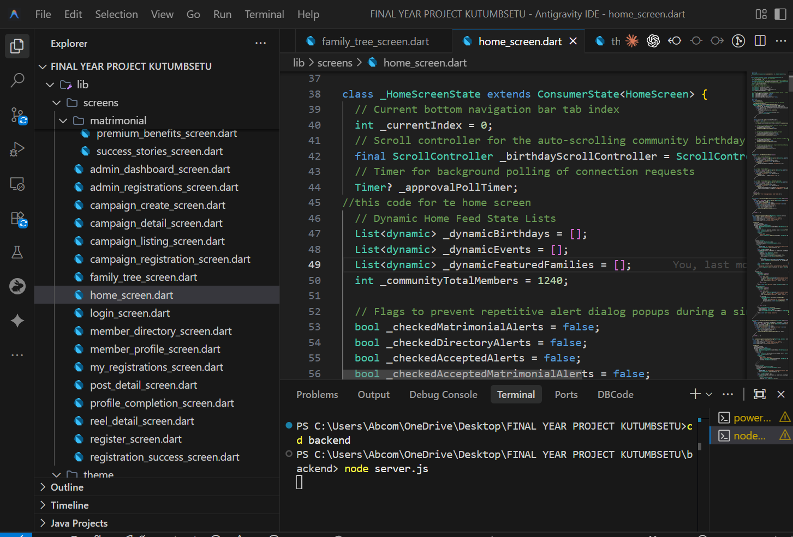
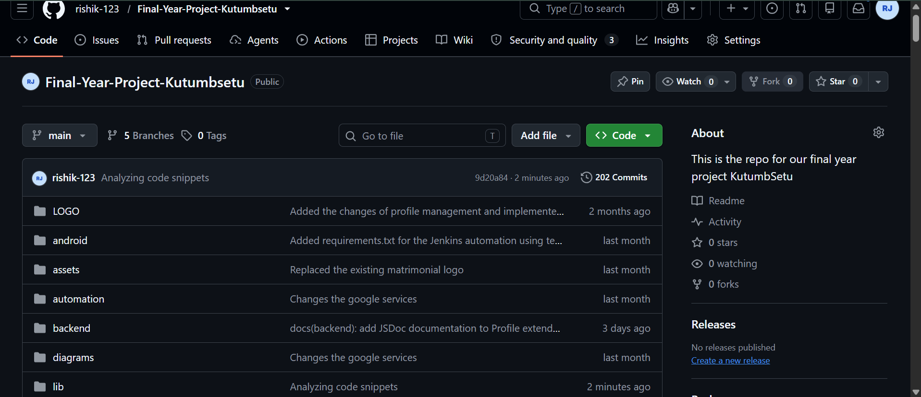
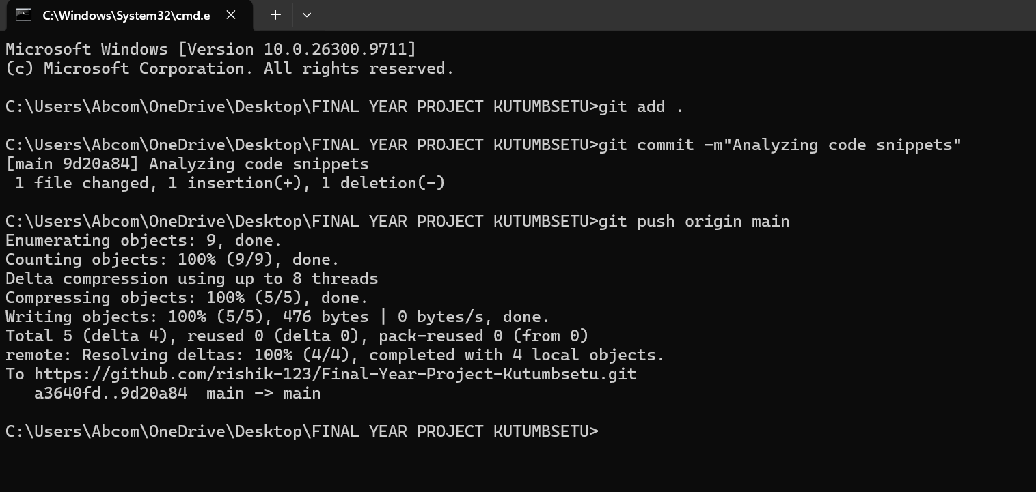
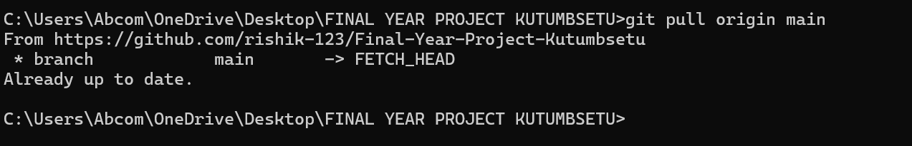

11.2 Jenkins Home Page and Successful Execution
Insert a screenshot of the Jenkins dashboard running on Windows. Also include the configured job and its execution result.
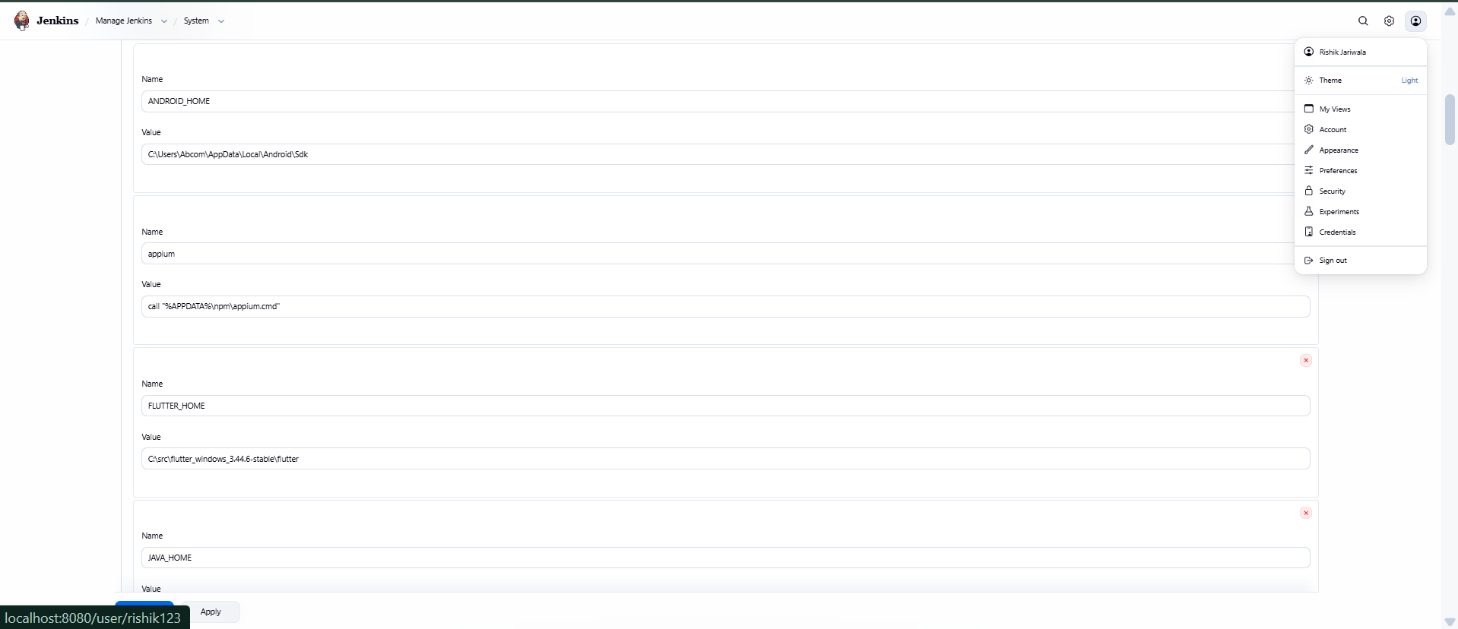
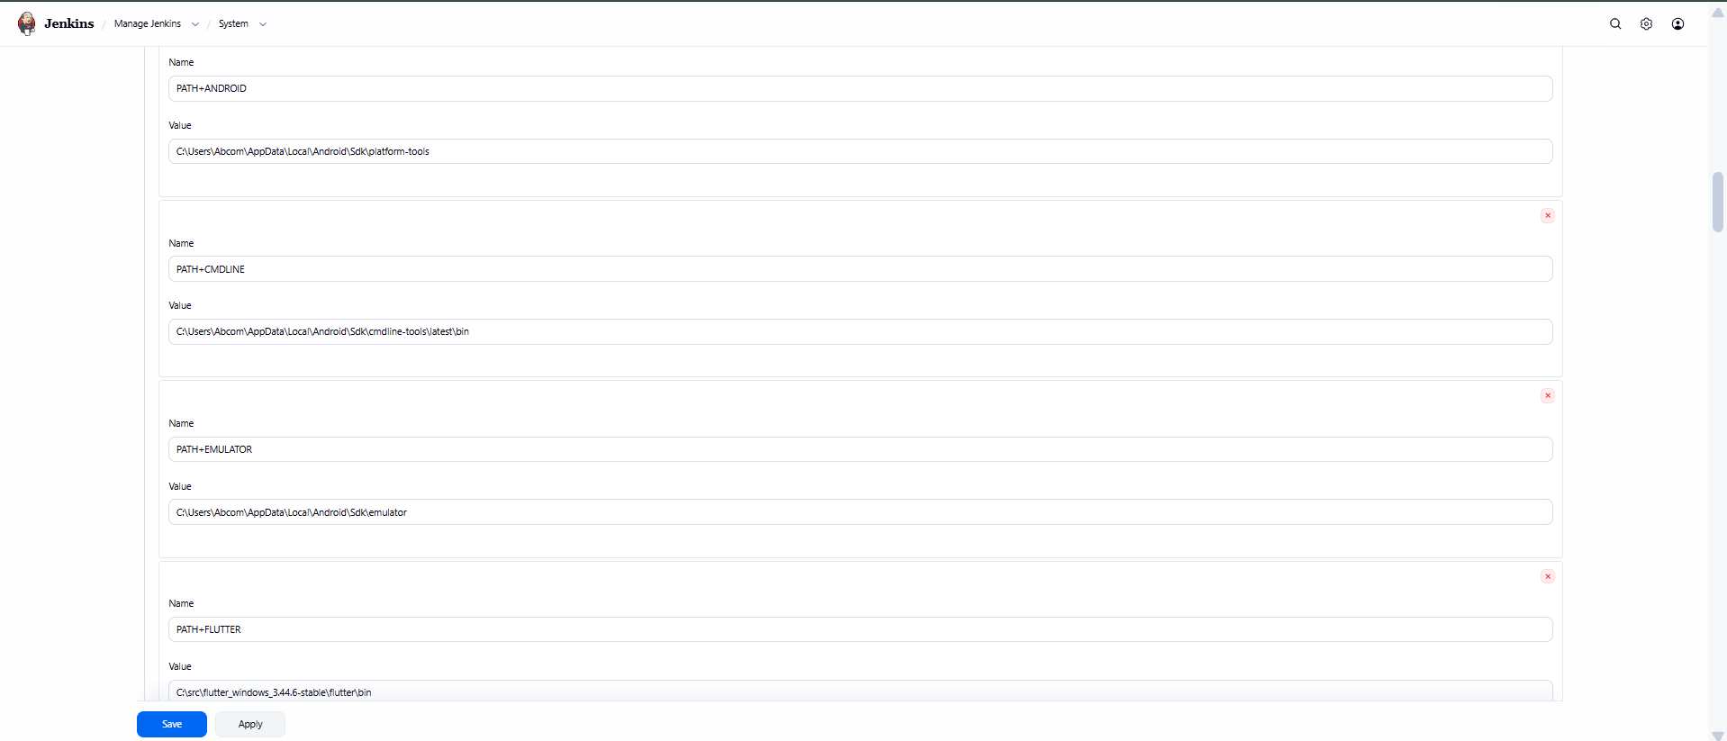
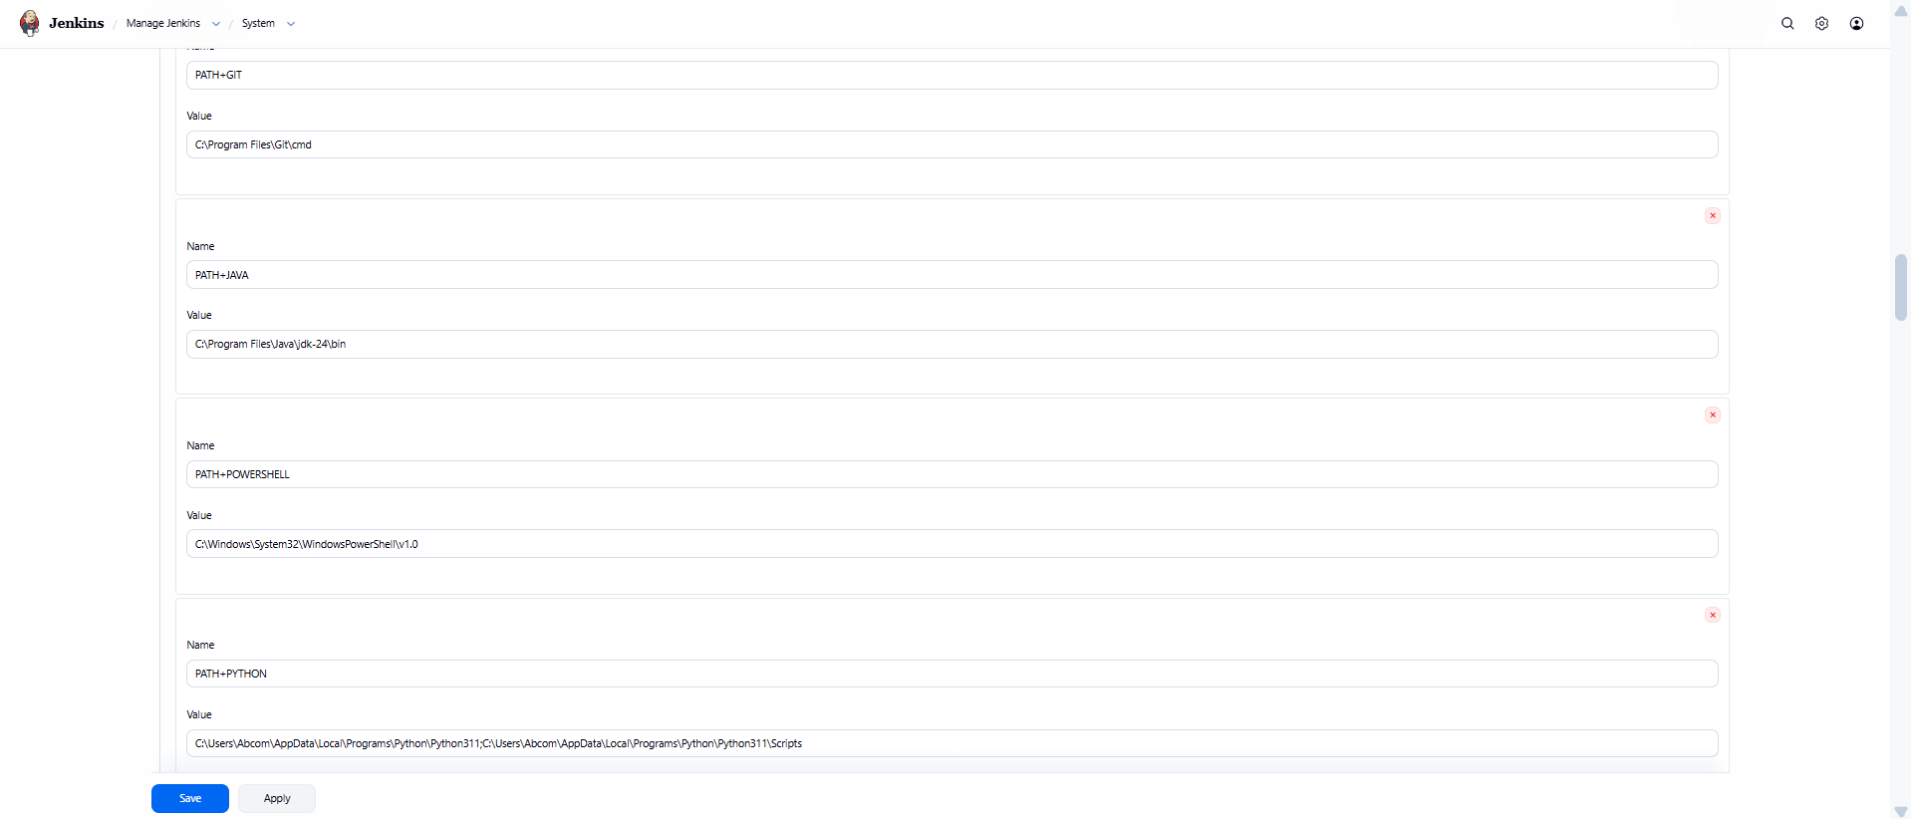
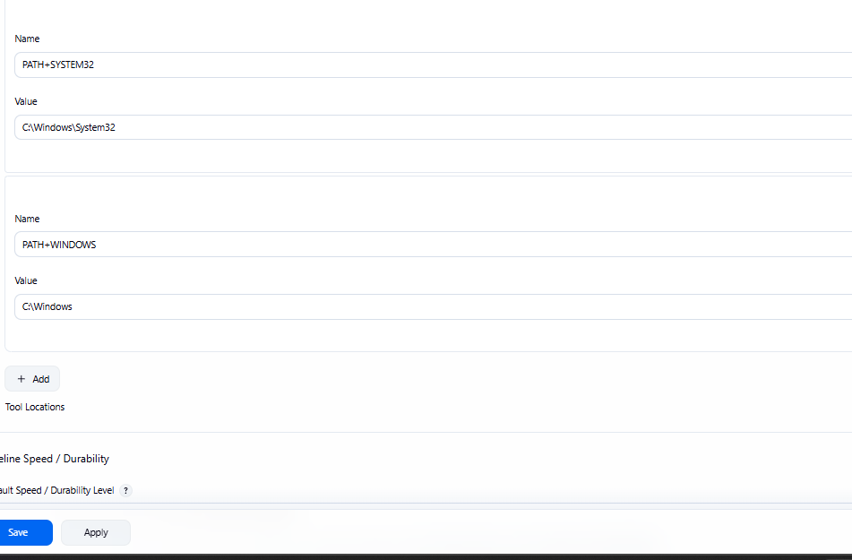
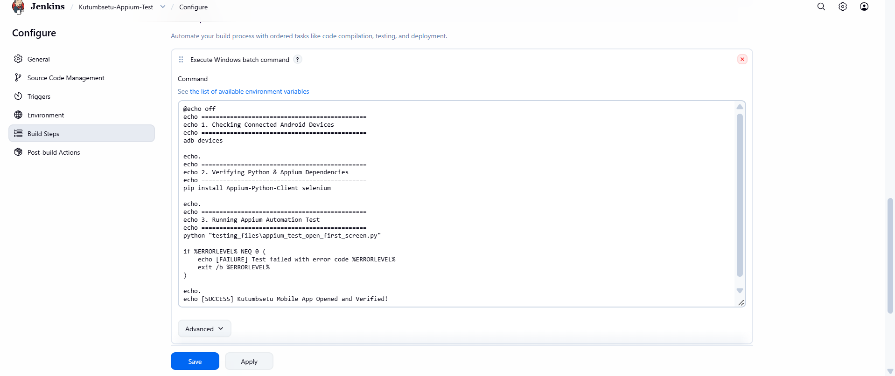
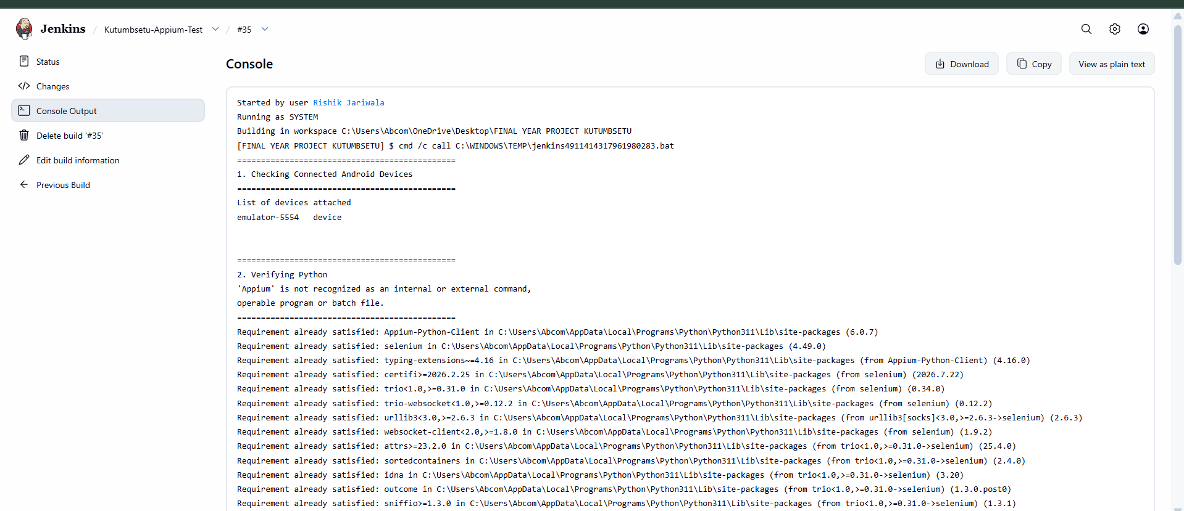
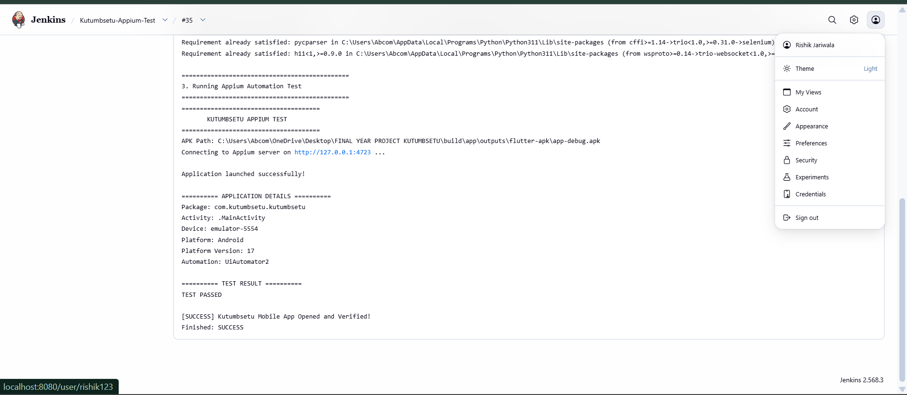
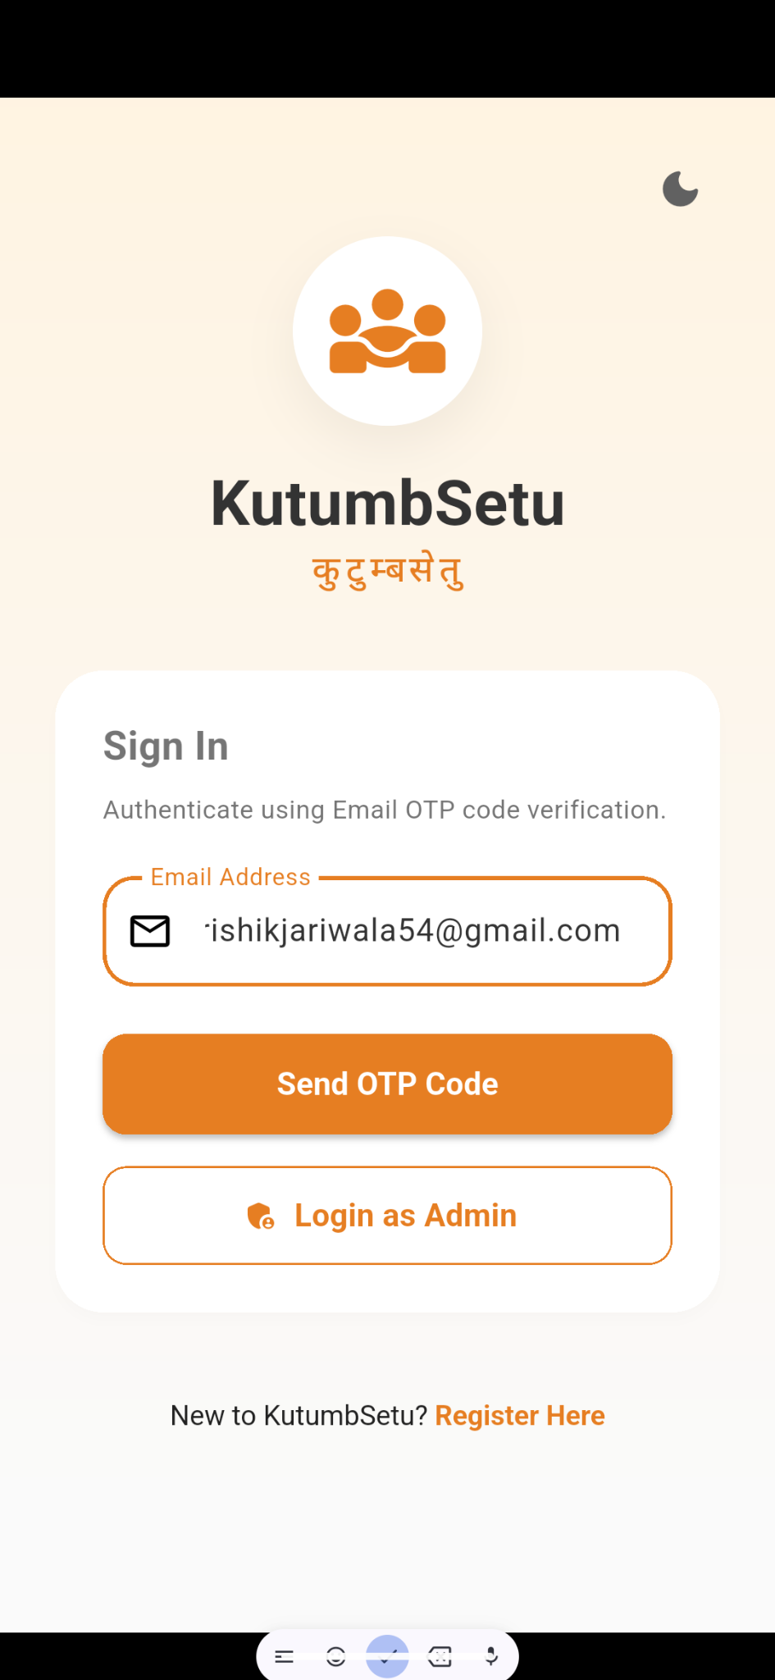

11.3 Mobile Application Testing Results (Appium)
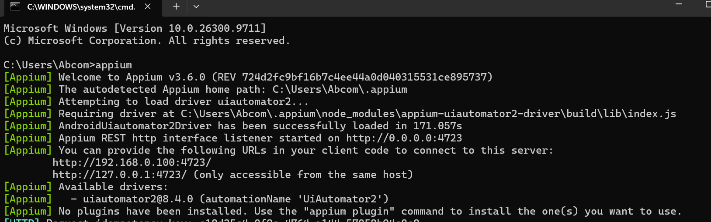
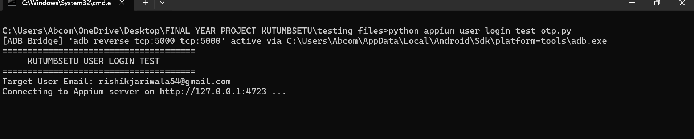
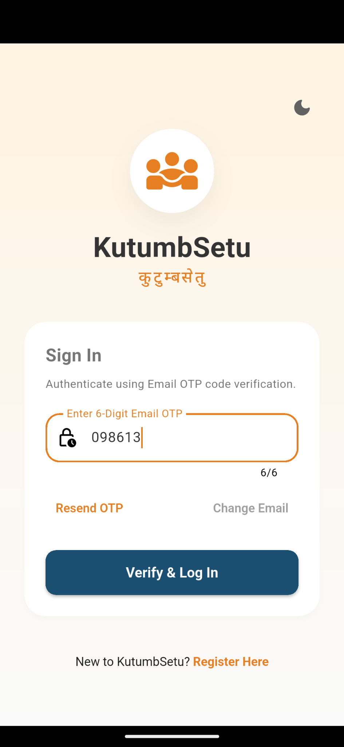
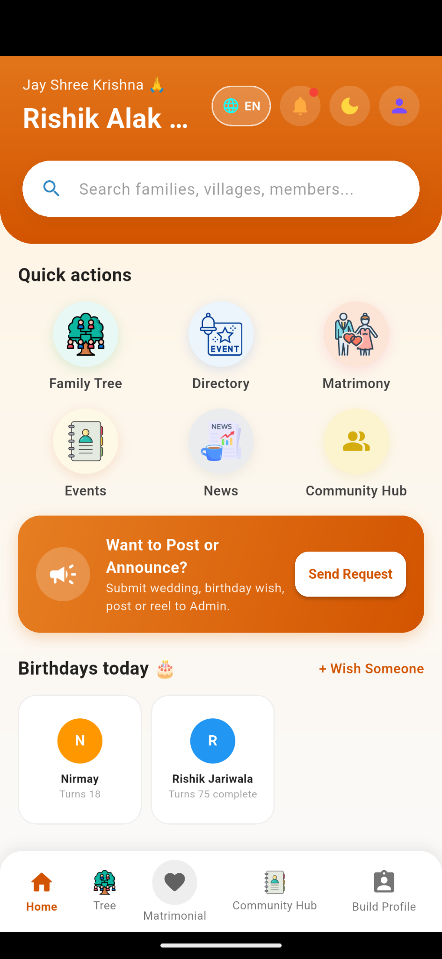

11.4 Docker Image and Container Execution
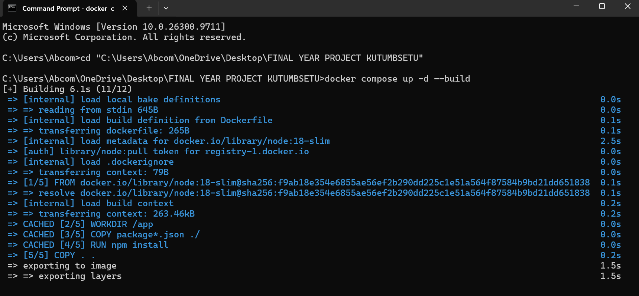
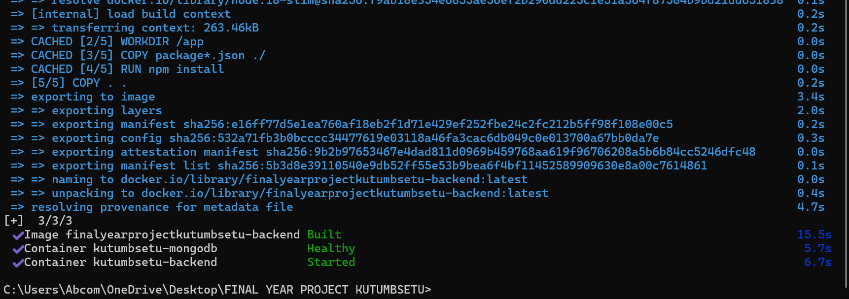
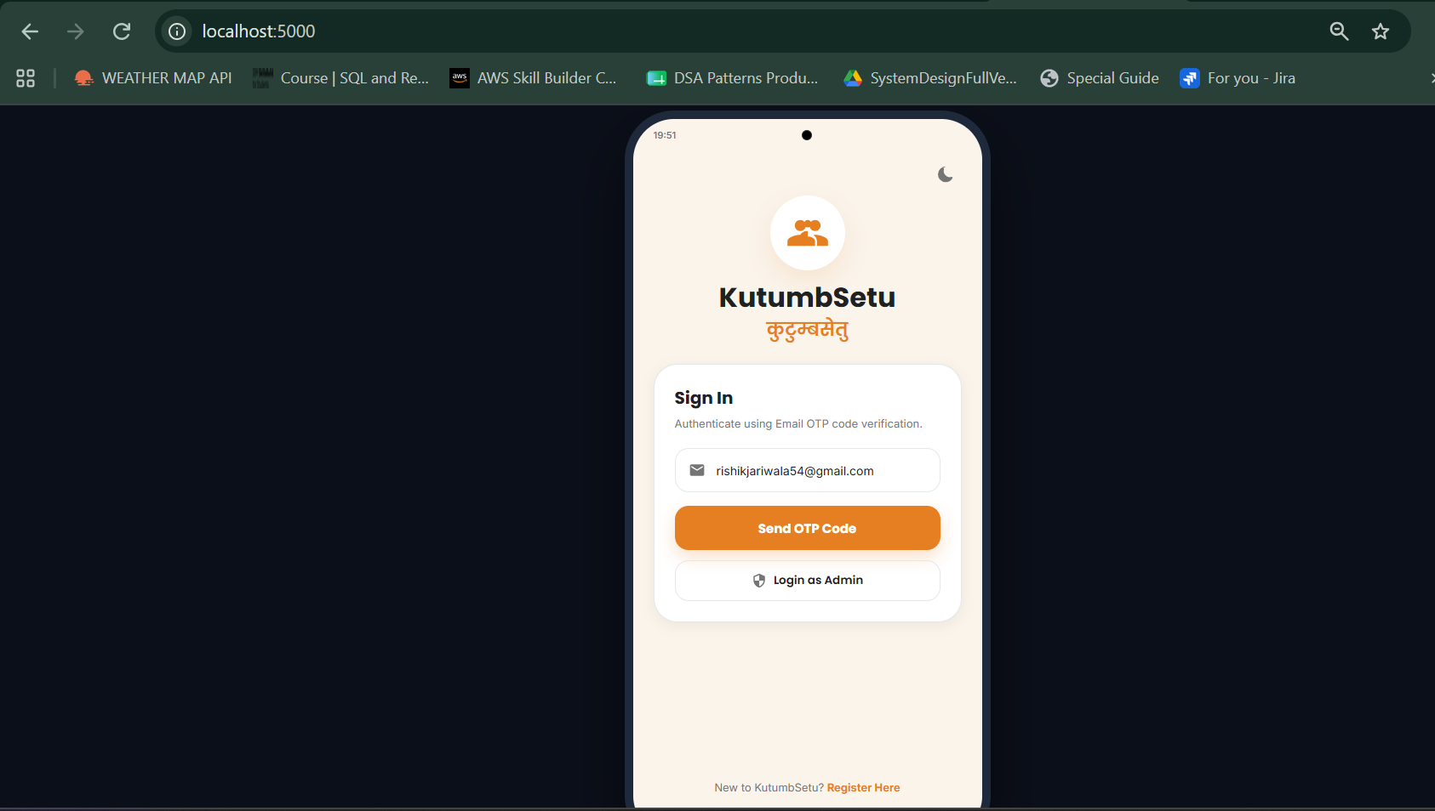
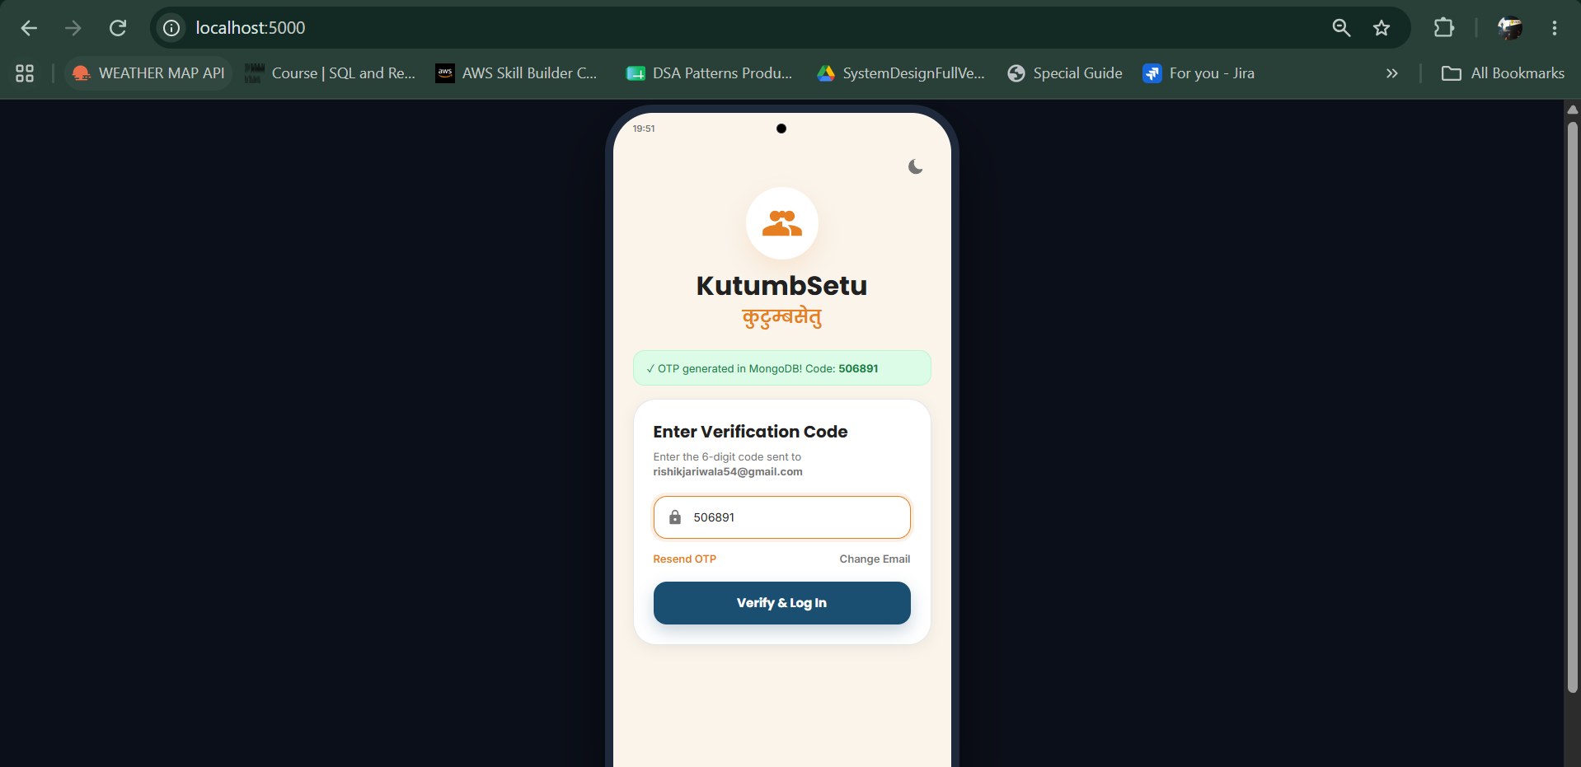
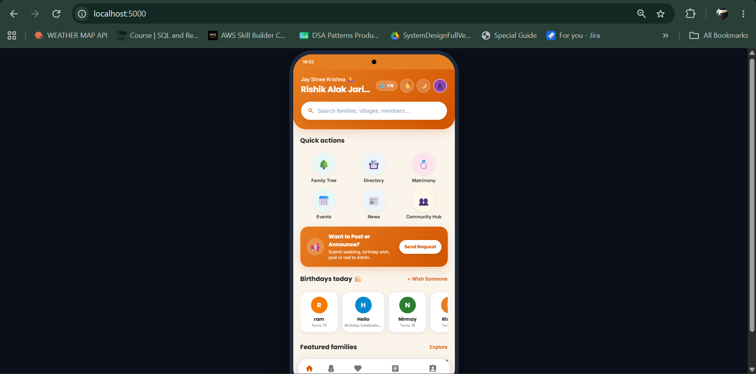

11.5 Ansible Playbook and Automation Execution Results
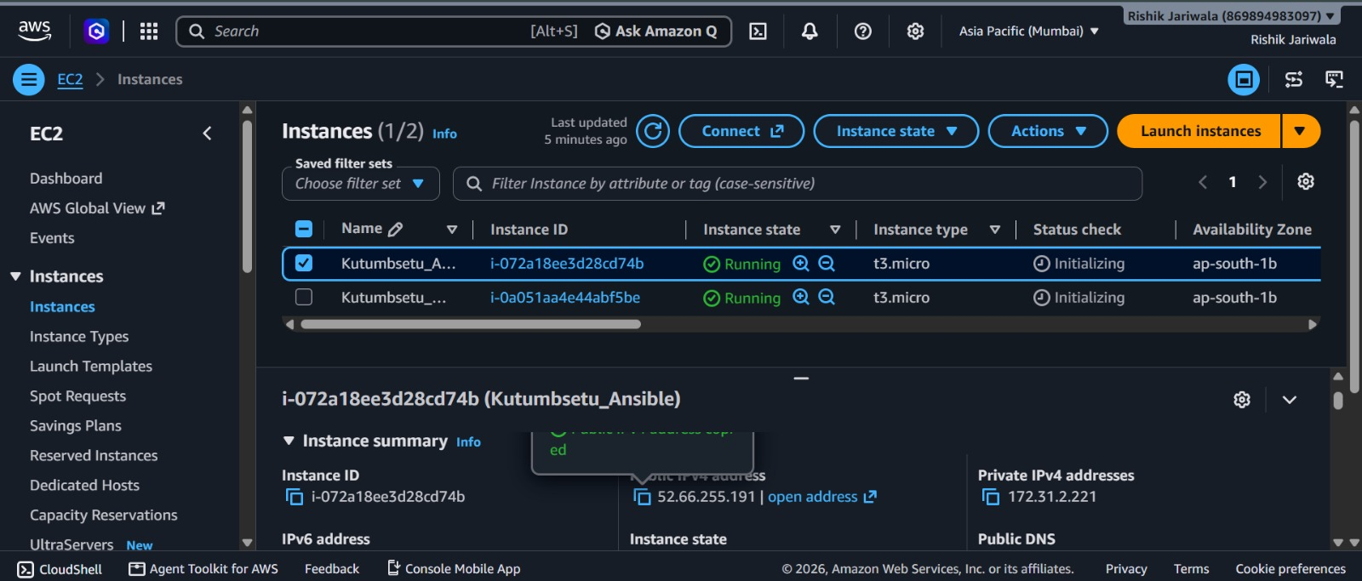
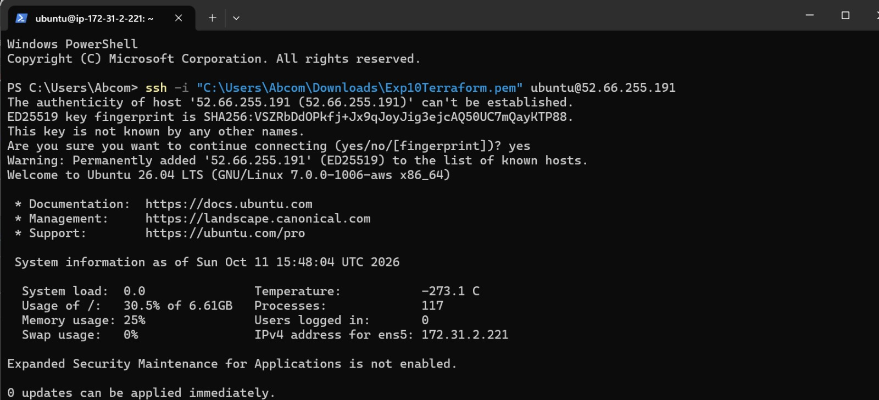
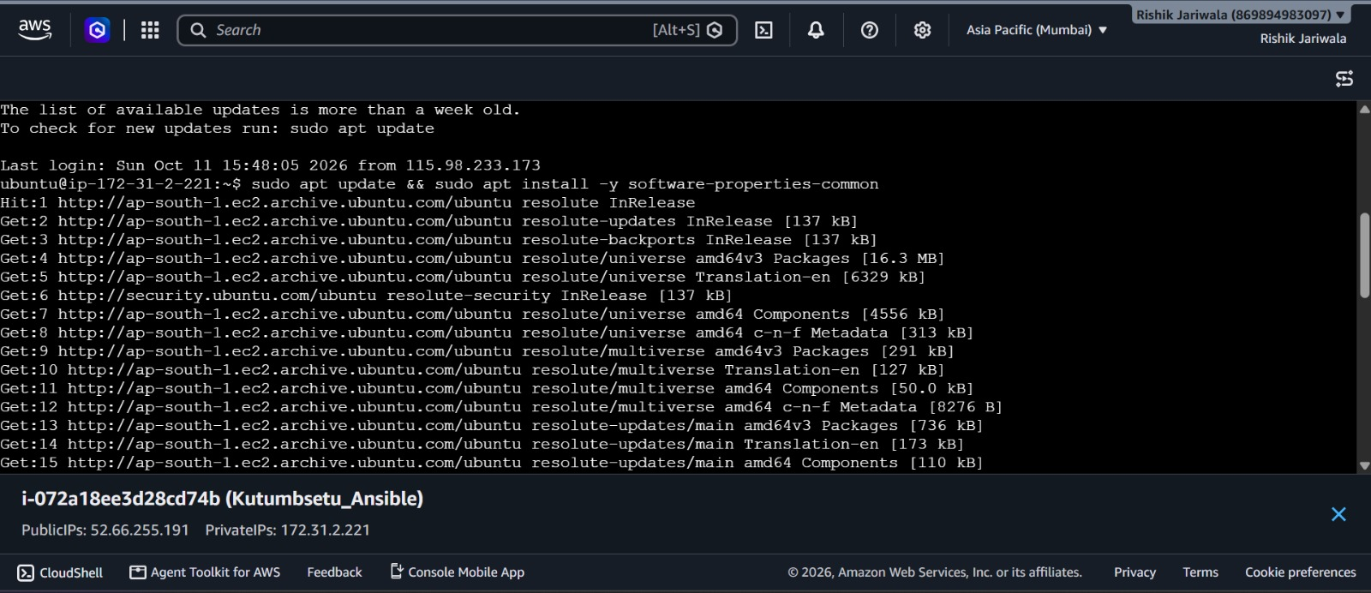
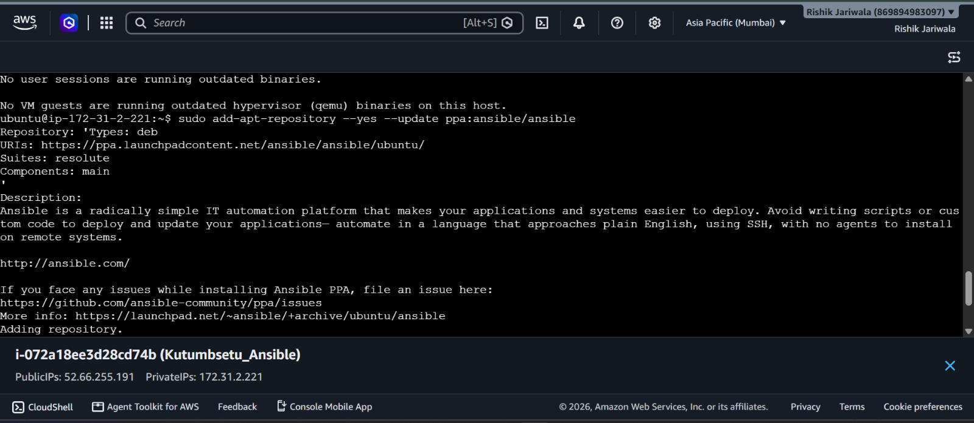
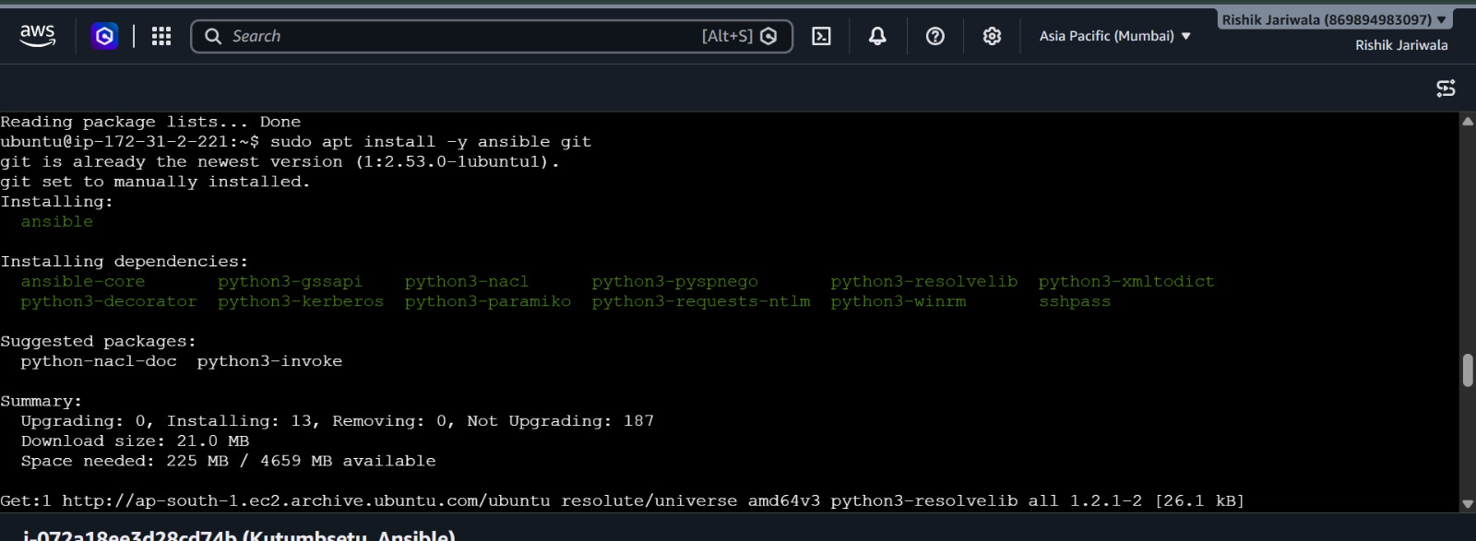
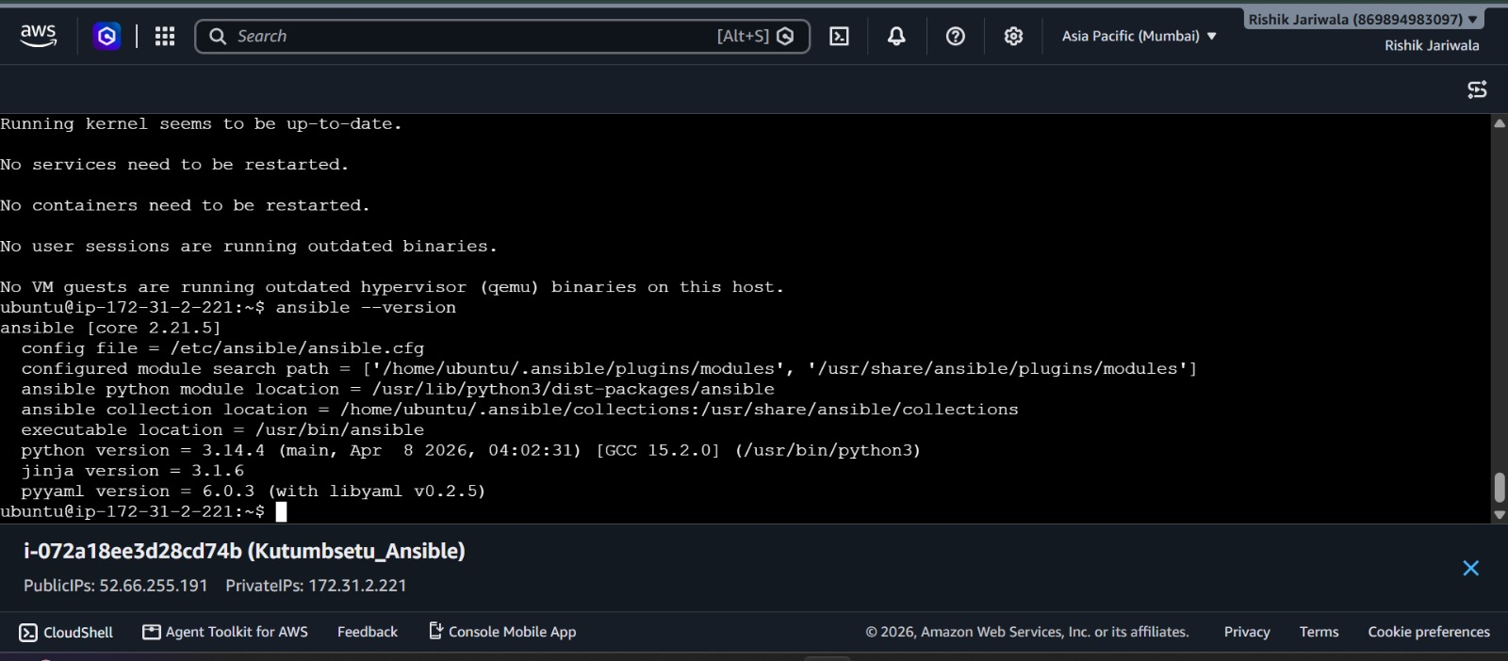
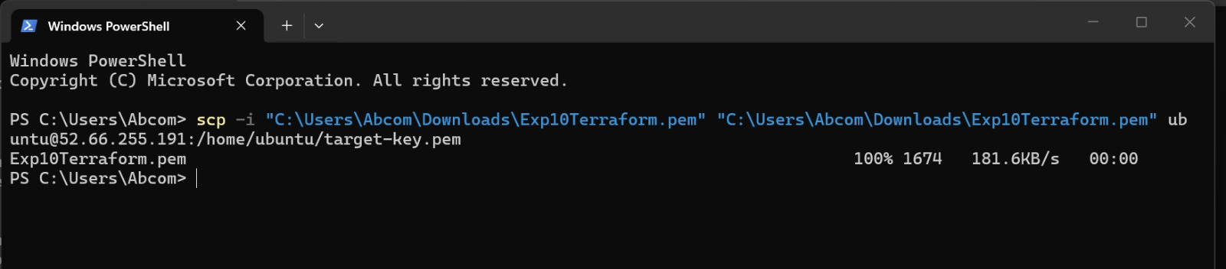
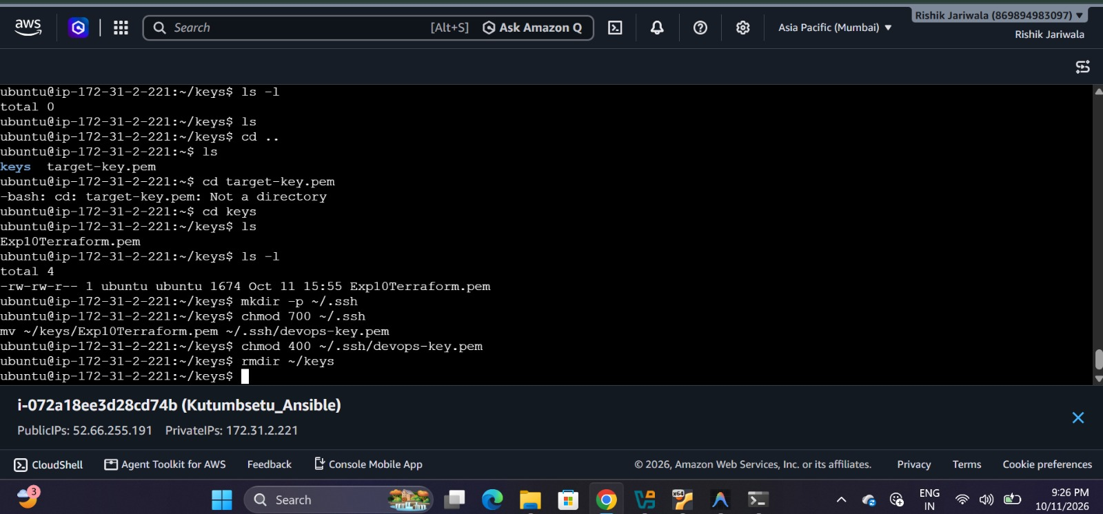
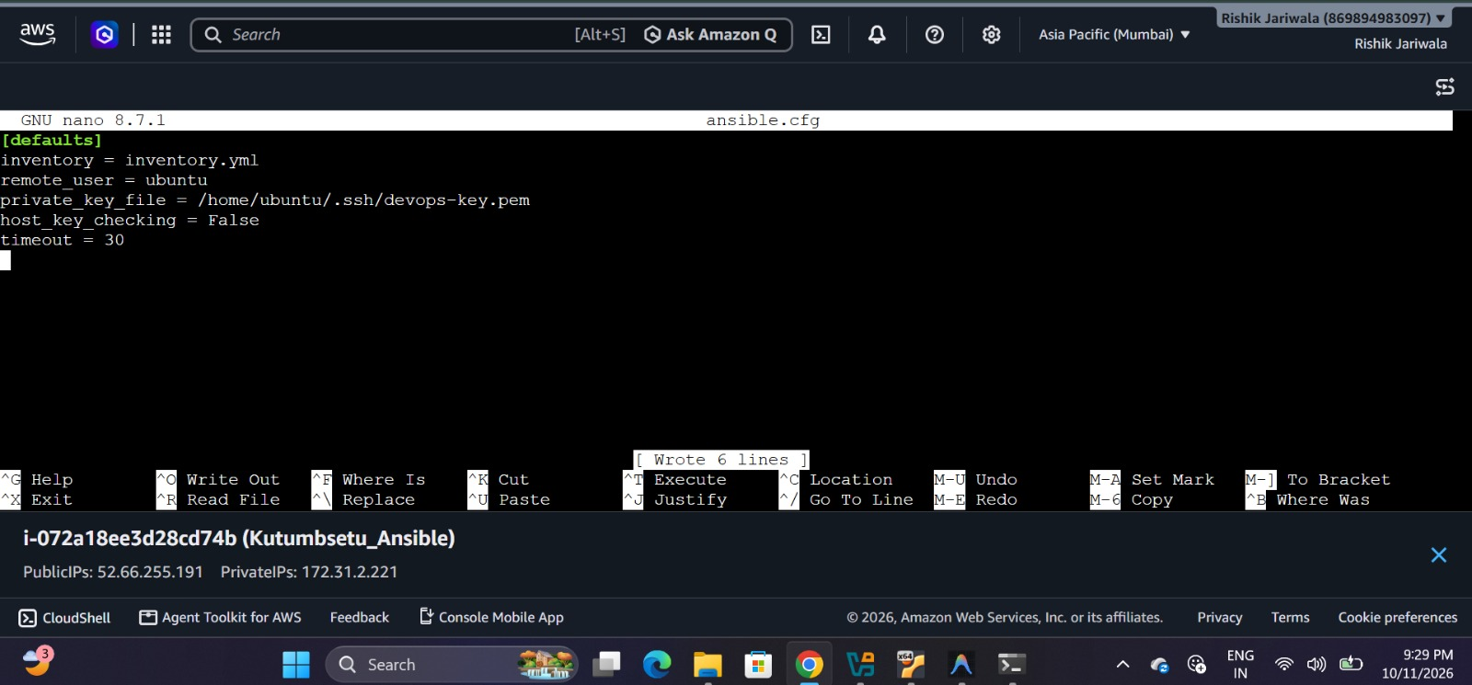
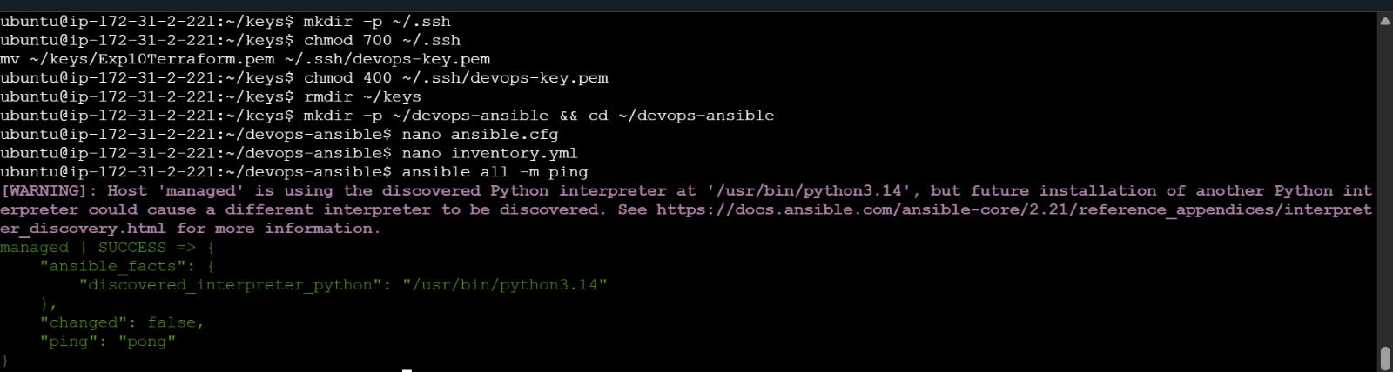
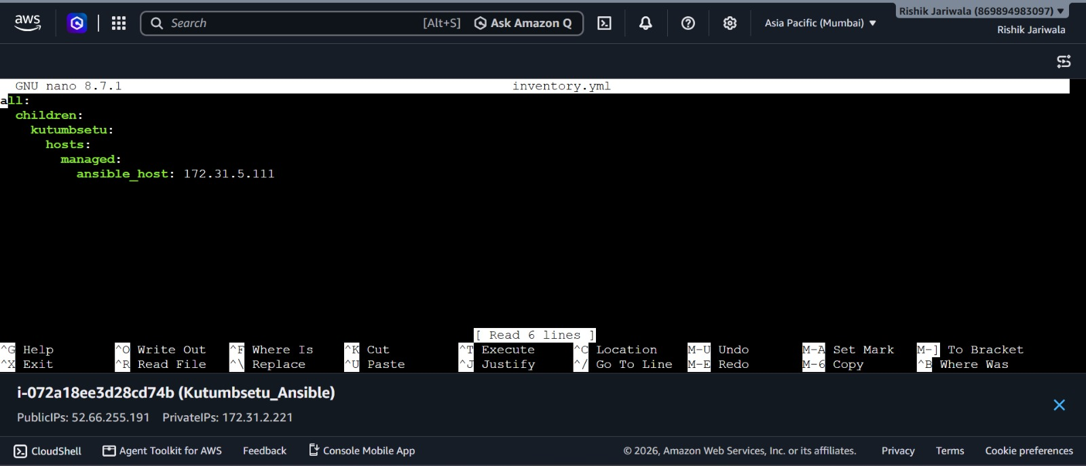
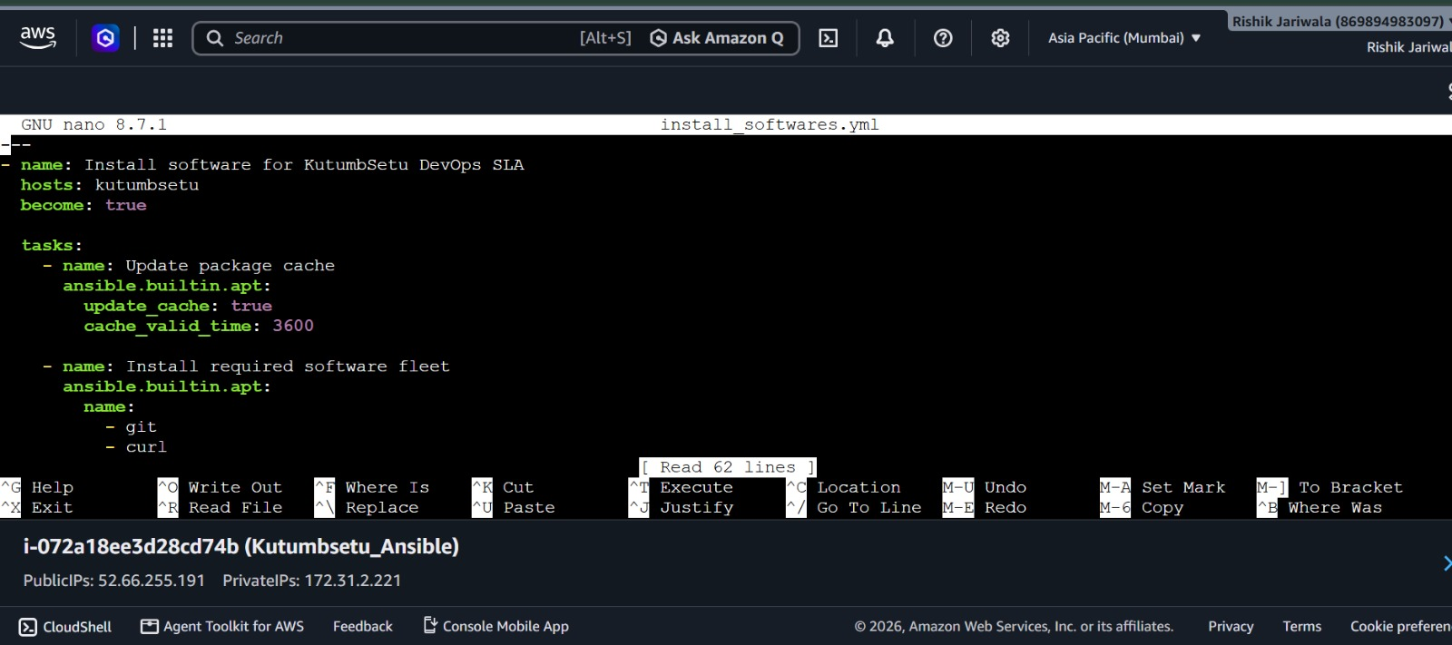
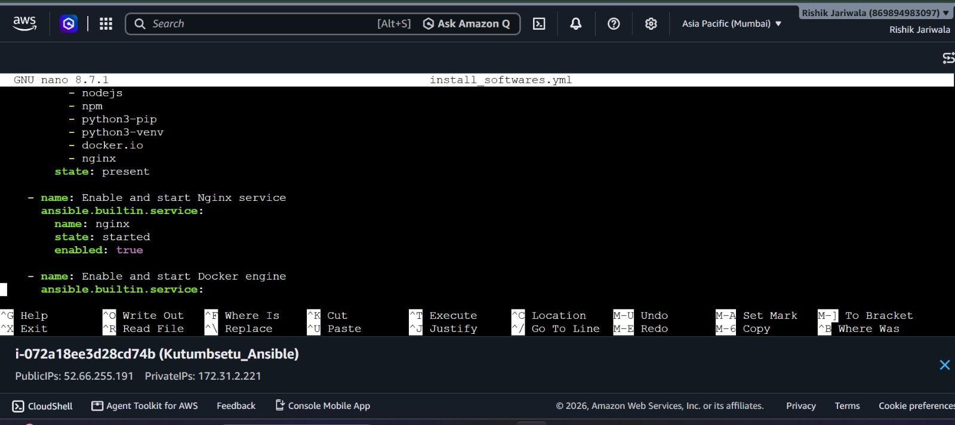
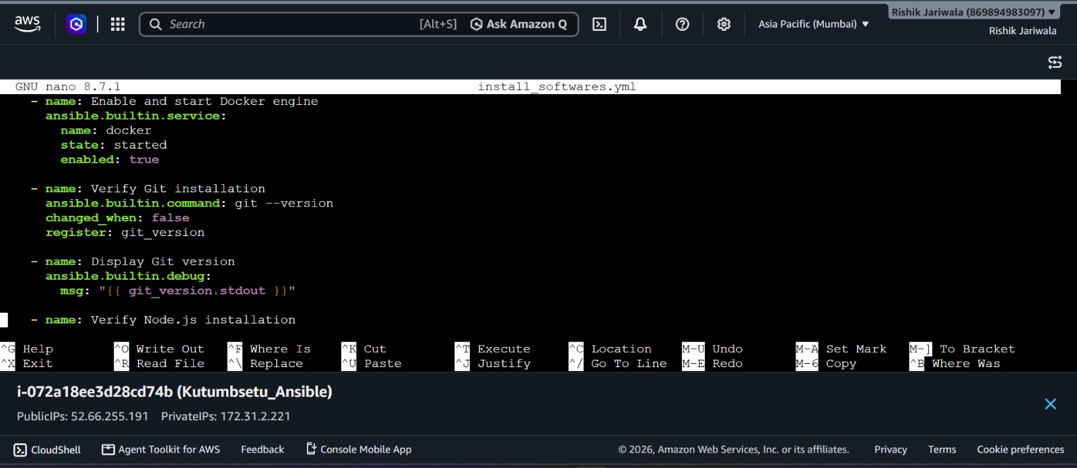
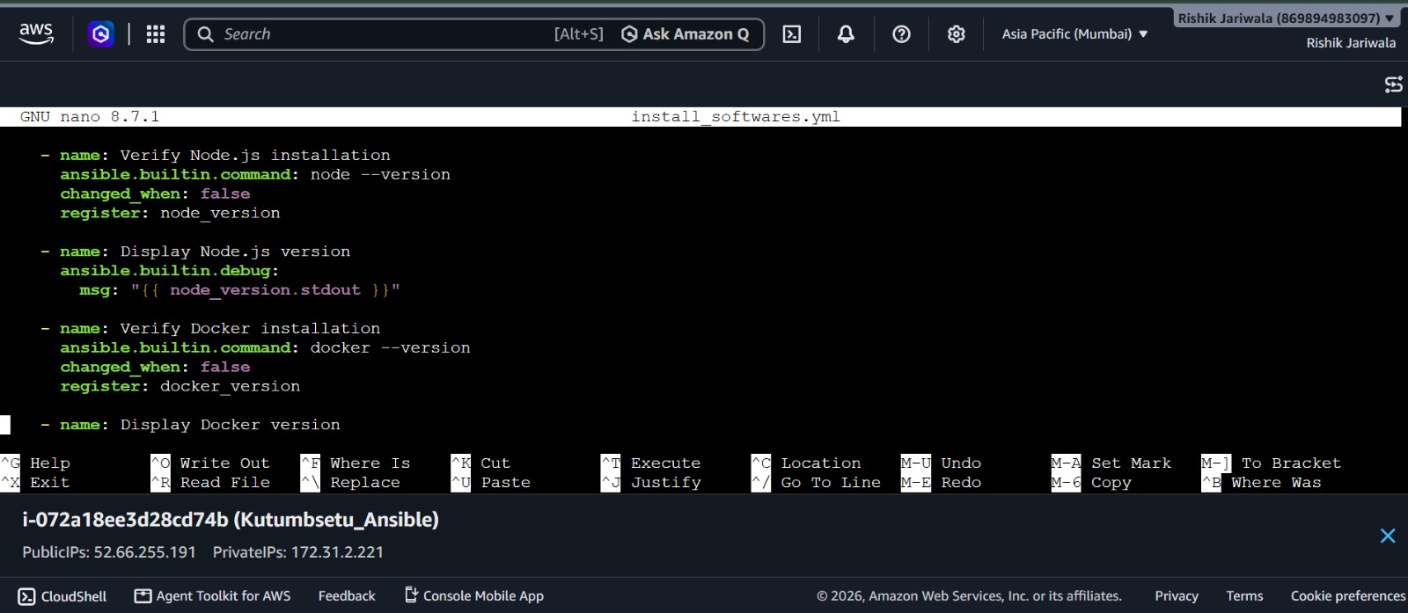
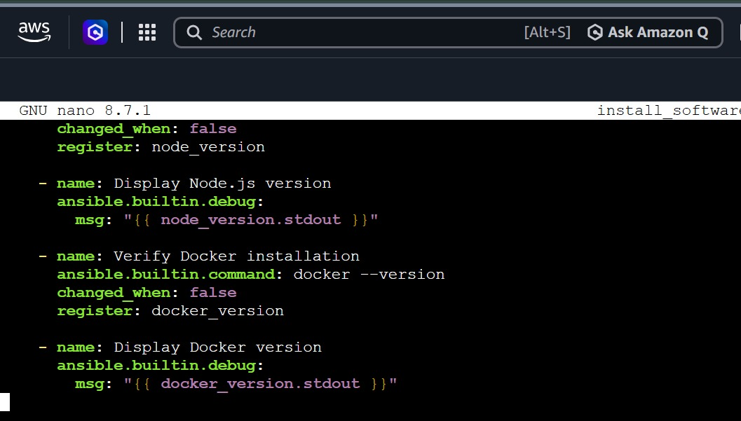

12. Summary of DevOps Implementation
The implementation of DevOps practices for the KutumbSetu project demonstrates how development, testing, deployment, and configuration management can be organized into a more systematic and reliable workflow. Git and GitHub support version control and source-code management, while Jenkins helps automate build and execution tasks. Mobile application testing helps verify the application's functionality, and Docker provides a consistent environment for running the backend with database connectivity. Ansible or Chef can further simplify software installation and environment configuration. These practices improve project maintainability, reduce manual effort, and provide a foundation for future enhancements and deployment. The successful completion of each activity is evaluated through the corresponding commands, screenshots, and testing results documented in this report.

13. Conclusion
The DevOps activities performed for the KutumbSetu project provided practical knowledge of version control, continuous integration, application testing, containerization, database connectivity, and configuration management. The use of Git and GitHub helps maintain code changes, Jenkins introduces automation into the development workflow, and Docker supports consistent application execution. Mobile application testing and automated software configuration further contribute to improving the reliability and maintainability of the project. Overall, this work strengthened the understanding of how DevOps tools can be integrated into a real-world software development project and established a foundation for more efficient development and deployment in the future.

14. References
- Git Documentation — https://git-scm.com/doc
- GitHub Documentation — https://docs.github.com/
- Jenkins Documentation — https://www.jenkins.io/doc/
- Flutter Documentation — https://docs.flutter.dev/
- Appium Documentation — https://appium.io/docs/en/latest/
- Docker Documentation — https://docs.docker.com/
- MongoDB Documentation — https://www.mongodb.com/docs/
- Ansible Documentation — https://docs.ansible.com/
- Chef Documentation — https://docs.chef.io/
- Node.js Documentation — https://nodejs.org/docs/

